Machine Learning Lab
Lab Report – Lab 2
Name | Rakshitaa Harnal
Section-Batch | C1-A1
Roll No. | 05
Subject | Machine Learning Lab

Lab No. | Lab 2
Lab Title | Regularized Regression (Ridge & Lasso) for House Price Prediction
Aim | To develop and compare Linear, Ridge and Lasso Regression models for predicting house prices using a suitable dataset.
Objectives | 1. Load, inspect and clean a housing dataset. 2. Perform EDA and outlier removal. 3. Build Ridge and Lasso models with GridSearchCV. 4. Evaluate using MAE, MSE, RMSE and R². 5. Compare with a Multiple Linear Regression baseline.
Dataset / Resources | USA Housing dataset (Usa_Housing.csv): 5000 rows, 7 columns. Python, Jupyter Notebook, pandas, NumPy, matplotlib, seaborn, scikit-learn.
Date of Performance | __ / __ / 2026

1. Theory

1.1 Linear Regression
Multiple Linear Regression models a continuous target (here, house price) as a weighted sum of input features: y = b0 + b1x1 + b2x2 + … + bnxn. The coefficients are found by minimising the sum of squared residuals (Ordinary Least Squares). It is simple and interpretable, but when features are correlated or the model is complex, the coefficients can become unstable and the model may overfit.

1.2 Ridge Regression (L2 Regularization)
Ridge Regression adds an L2 penalty, alpha × Σ(bj²), to the OLS loss. This shrinks coefficients towards zero without making them exactly zero, which reduces variance and handles multicollinearity. The hyperparameter alpha controls the strength of the penalty: alpha = 0 gives ordinary linear regression, while a very large alpha leads to underfitting.

1.3 Lasso Regression (L1 Regularization)
Lasso (Least Absolute Shrinkage and Selection Operator) adds an L1 penalty, alpha × Σ|bj|. Because of this penalty, some coefficients can become exactly zero, so Lasso performs automatic feature selection and produces sparse models. It is useful when only a few features are expected to matter.

1.4 Hyperparameter Tuning and Evaluation Metrics
GridSearchCV tries every value in a parameter grid using k-fold cross-validation and returns the best estimator. Models are evaluated with: MAE (average absolute error), MSE (average squared error), RMSE (square root of MSE, in the same unit as the target) and R² (proportion of variance in the target explained by the model; closer to 1 is better).

1.5 Outlier Removal using the IQR Method
The Interquartile Range is IQR = Q3 − Q1. Values below Q1 − 1.5×IQR or above Q3 + 1.5×IQR are treated as outliers and removed, which prevents extreme values from distorting the fitted model.

2. Code (GitHub)
The complete Python notebook for this lab has been uploaded to GitHub:
GitHub URL: https://github.com/<your-username>/<repository-name>
Key code used in the experiment:
df = pd.read_csv("Usa_Housing.csv")
df.drop(['Address'], axis=1, inplace=True)

Q1 = df["Avg. Area Income"].quantile(0.25)
Q3 = df["Avg. Area Income"].quantile(0.75)
IQR = Q3 - Q1
df = df[(df["Avg. Area Income"] >= Q1-1.5*IQR) & (df["Avg. Area Income"] <= Q3+1.5*IQR)]

X = df.drop("Price", axis=1); y = df["Price"]
X_train, X_test, y_train, y_test = train_test_split(X, y, test_size=0.2, random_state=42)

grid_ridge = GridSearchCV(Ridge(), {"alpha":[0.01,0.1,1,10,100]}, cv=5, scoring="r2")
grid_ridge.fit(X_train, y_train)

grid_lasso = GridSearchCV(Lasso(max_iter=5000), {"alpha":[0.001,0.01,0.1,1,10]}, cv=5, scoring="r2")
grid_lasso.fit(X_train, y_train)

mlr = LinearRegression().fit(X_train, y_train)

3. Procedure and Materials Used

Materials
- Hardware: Laptop/PC with Python 3 environment
- Software: Jupyter Notebook, Python libraries – pandas, NumPy, matplotlib, seaborn, scikit-learn
- Dataset: Usa_Housing.csv (5000 records; features: Avg. Area Income, Avg. Area House Age, Avg. Area Number of Rooms, Avg. Area Number of Bedrooms, Area Population, Address; target: Price)

Procedure
- Import the required libraries and load the dataset with pd.read_csv().
- Inspect the data using head(), tail(), shape, info() and describe(); check for null values and duplicates (none found).
- Drop the non-numeric Address column and set float display format.
- Plot a correlation heatmap to understand relationships between features and Price.
- Draw boxplots for Avg. Area Income and Price; remove income outliers using the IQR rule (5000 → 4968 rows).
- Perform univariate and bivariate analysis using scatter plots and histograms.
- Split the data into 80% training and 20% testing sets (random_state = 42).
- Train Ridge Regression, tune alpha with GridSearchCV (5-fold CV) and evaluate with MAE, MSE, RMSE and R².
- Train Lasso Regression with GridSearchCV and evaluate R².
- Train a Multiple Linear Regression model and plot Actual vs Predicted prices.

4. Output Screenshots and Descriptions
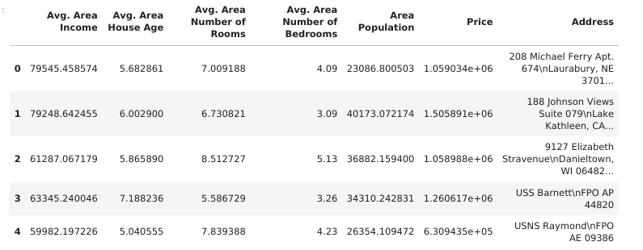
Output 1: First five records of the dataset (df.head())
This output shows the first five rows of the USA Housing dataset loaded from the CSV file. It contains five numeric features: average area income, house age, number of rooms, number of bedrooms and area population, along with the Price target and a text Address column. The values of Price are in the order of 10^6, while the other features are on very different scales. The Address column is a free-text string that cannot be used directly in a regression model. The dataset has 5000 rows and 7 columns, as confirmed by df.shape.
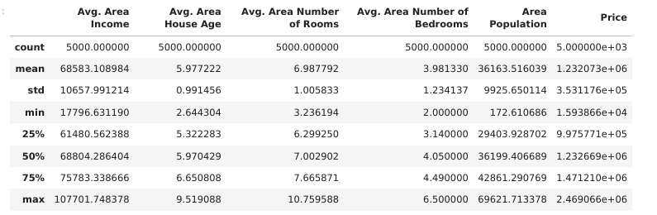
Output 2: Statistical summary of the dataset (df.describe())
The describe() output gives count, mean, standard deviation, min, quartiles and max for each numeric column. All columns have a count of 5000, confirming there are no missing values. The mean house price is about 1.23 million with a standard deviation of about 3.53 × 10^5. Average area income has a mean near 68,583, with a minimum of 17,796 that is far below the quartiles, hinting at outliers. Mean and median are very close for most features, indicating roughly symmetric distributions.
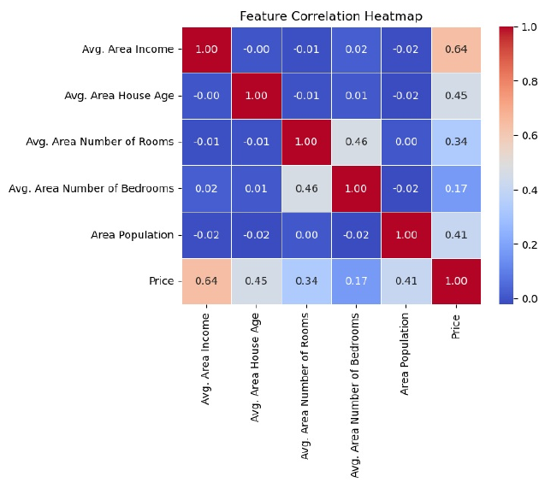
Output 3: Feature correlation heatmap
The heatmap displays pairwise Pearson correlations between all variables. Avg. Area Income has the strongest positive correlation with Price (0.64), followed by House Age (0.45), Area Population (0.41) and Number of Rooms (0.34). Number of Bedrooms has the weakest correlation with Price (0.17). The independent features are almost uncorrelated with each other (values near 0), except Rooms and Bedrooms (0.46). This low multicollinearity means the features carry mostly independent information for the model.
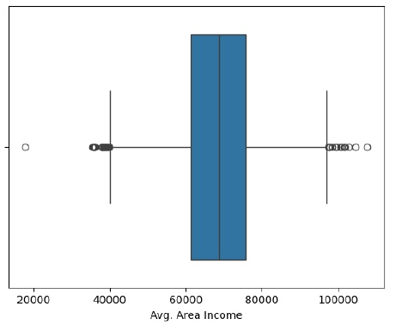
Output 4: Boxplot of Avg. Area Income
The boxplot shows the distribution of average area income, with the median near 68,800 and a box spanning roughly 61,000 to 76,000. Several points lie beyond the whiskers on both sides, including one extreme low value near 18,000. These points are outliers according to the 1.5 × IQR rule. Because income is the most influential feature for Price, these outliers could distort the regression fit. Hence they were removed using the IQR method, reducing the data from 5000 to 4968 rows.
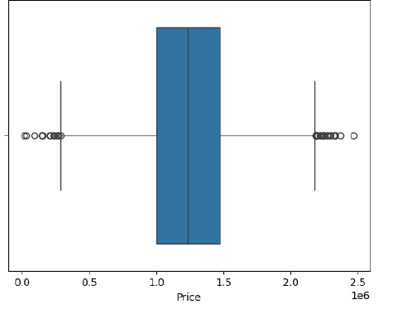
Output 5: Boxplot of Price
The boxplot of Price shows a median of about 1.23 million with a fairly symmetric box. A few outliers appear at the low end (below about 0.3 million) and at the high end (above about 2.2 million). The distribution is balanced on both sides of the median, which suggests the target is close to normally distributed. These price outliers were retained since they are plausible house prices, and only the income outliers were removed.
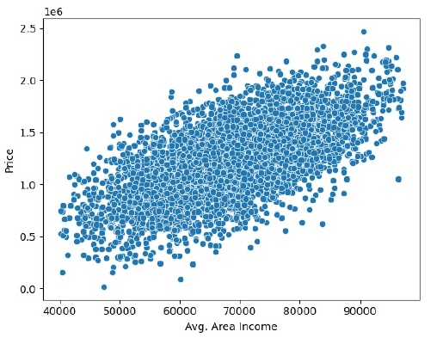
Output 6: Scatter plot of Avg. Area Income vs Price
This scatter plot (drawn after outlier removal) shows a clear positive, roughly linear trend: areas with higher average income tend to have higher house prices. The points form a wide, elongated cloud, meaning income alone does not fully explain price and other features also contribute. The relationship matches the correlation of 0.64 seen in the heatmap. The roughly linear pattern justifies the use of linear-type models such as Ridge, Lasso and Linear Regression.
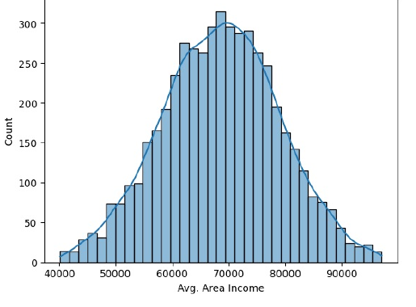
Output 7: Histogram with KDE of Avg. Area Income
The histogram of income after outlier removal is bell-shaped and symmetric, centred at about 70,000, with incomes ranging from roughly 40,000 to 97,000. The KDE curve closely follows the bars, showing the feature is approximately normally distributed. The removal of extreme values has removed the long tails. Such a distribution is well suited to linear models, which assume well-behaved, roughly Gaussian features.
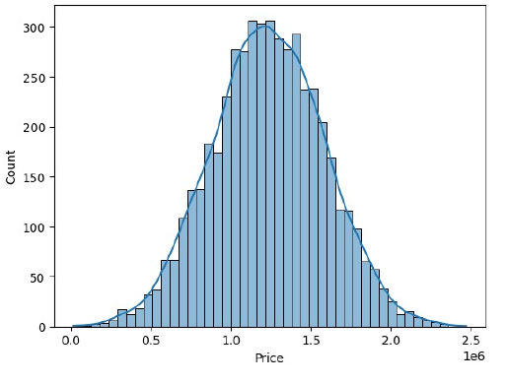
Output 8: Histogram with KDE of Price
The target variable Price also follows a bell-shaped, nearly normal distribution, centred at about 1.2 million. Most houses are priced between 0.75 and 1.75 million, with very few at the extremes. There is no strong skewness, so no log-transformation of the target was needed. A normally distributed target generally leads to well-behaved residuals and good performance with regression models.
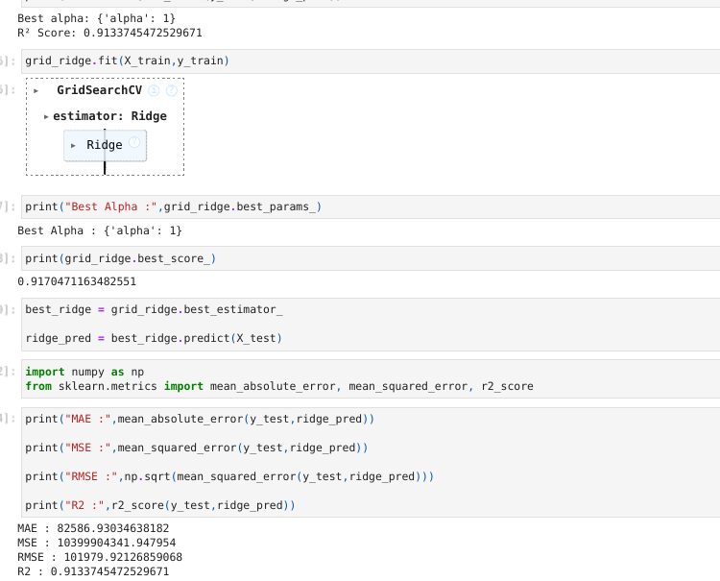
Output 9: Ridge Regression – best alpha and evaluation metrics
GridSearchCV tested alpha values 0.01, 0.1, 1, 10 and 100 using 5-fold cross-validation, and selected alpha = 1 as the best value. The best cross-validation R² was about 0.917, and the test R² was 0.9134, which shows the model generalises well. The errors on the test set are MAE ≈ 82,587, MSE ≈ 1.04 × 10^10 and RMSE ≈ 101,980. An RMSE of about 0.1 million on an average price of 1.23 million is a reasonable error for this data. The tuned model scored the same as the default Ridge model.
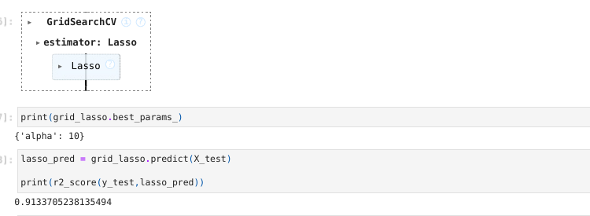
Output 10: Lasso Regression – best alpha and R² score
GridSearchCV over alpha values 0.001 to 10 selected alpha = 10 for Lasso, which is the largest value in the grid. The R² on the test set is 0.91337, almost identical to Ridge (0.91337). This indicates that all five features contribute usefully, so the L1 penalty does not need to drop any of them. Since the best alpha lies at the edge of the grid, a larger range could be tried to confirm that it is truly optimal.
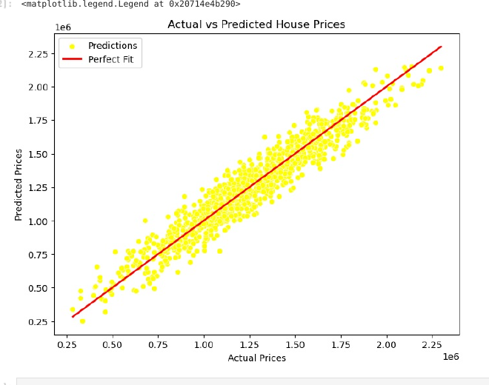
Output 11: Actual vs Predicted House Prices (Linear Regression)
The scatter plot compares actual test prices (x-axis) with the prices predicted by the multiple linear regression model (y-axis). The red line represents a perfect fit, where predicted equals actual. The yellow points cluster tightly around this line across the full price range, showing that the model predicts prices accurately. Small deviations appear at the lowest and highest prices, which is expected. This visual agrees with the high R² of about 0.91 for all the models.

Result Summary
Model | Best alpha | R² (Test)
Ridge Regression | 1 | 0.9134
Lasso Regression | 10 | 0.9134

Conclusion: Ridge and Lasso regression both predicted house prices with an R² of about 0.91 on the test set. Their performance was virtually identical, as the features are largely uncorrelated and all useful. Average area income was the most influential factor.

5. Viva Questions with Solutions
Q1. What is the difference between Ridge and Lasso regression?
Ans: Ridge uses an L2 penalty (sum of squared coefficients) that shrinks coefficients but keeps them non-zero. Lasso uses an L1 penalty (sum of absolute coefficients) that can shrink some coefficients exactly to zero, thereby performing feature selection.
Q2. What is the role of the hyperparameter alpha?
Ans: Alpha controls the strength of regularization. A small alpha makes the model close to ordinary linear regression (risk of overfitting), while a large alpha shrinks coefficients heavily (risk of underfitting). It is selected using cross-validation, here with GridSearchCV.
Q3. Why did we remove outliers using the IQR method, and how does it work?
Ans: Outliers can pull the regression line and distort coefficients. The IQR method computes IQR = Q3 − Q1 and removes values below Q1 − 1.5×IQR or above Q3 + 1.5×IQR. In this lab it removed 32 rows of income outliers (5000 → 4968).
Q4. What does an R² score of 0.913 mean?
Ans: R² is the proportion of variance in the target explained by the model. An R² of 0.913 means about 91.3% of the variation in house prices on the test data is explained by the input features, which indicates a good fit.
Q5. What is the purpose of GridSearchCV and cv = 5?
Ans: GridSearchCV exhaustively tries every combination of hyperparameters in the grid and evaluates each using k-fold cross-validation. With cv = 5, the training data is split into five folds; the model trains on four and validates on one, rotating five times. The average score is used to choose the best alpha, which gives a more reliable estimate than a single split.

